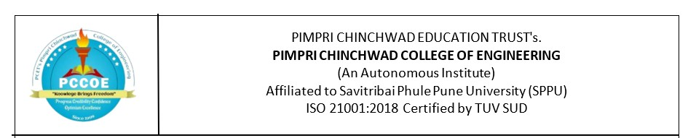

T.Y. B. TECH | Year: 2025 – 26 | Semester: 6
Name of the Student:Mrinmayee Pramod  Kulkarni |  | PRN: 124B2B025
Branch: Computer Engineering |  | Division: C
Date:18/2/2026

Assignment 7
Assignment Title:
Design a web application for e-commerce or students feedback review systems or any other applications with MongoDB Backend. using React.js and Express.
Objectives
• To understand backend development using Node.js and to use React.js for frontend development
• To learn routing and middleware using Express.js
• To design a simple e-commerce / Student feedback
• To store and manage data using MongoDB
• To understand client–server communication
• To perform basic CRUD operations

Outcomes
• Develop a functional Student feedback review system
• Implement server-side logic using Node.js and Express and frontend logic using React.js
• Store and retrieve data from MongoDB
• Understand REST API concepts
• Improve full-stack web development skills
Theory: Student Feedback Review System
- Introduction
The Student Feedback Review System is a web-based application developed using the MERN stack. It allows students to submit feedback, which is stored in a database and displayed on the website. The system ensures smooth communication between frontend and backend while managing data efficiently.
- Technologies Used
- React.js – for designing user interface
- Node.js – for backend execution
- Express.js – for handling server and APIs
- MongoDB – for storing feedback data
- MongoDB Compass – for viewing and managing database

- Working of the System
1. User Input
- The user enters name and feedback in the form on the website (React frontend)
2. Data Transmission
- The data is sent to the backend using HTTP POST request
3. Server Processing
- The backend (Node.js + Express.js) receives the data
- It processes the request and sends it to MongoDB
4. Data Storage
- The data is stored in MongoDB as a document:
{
"name": "Mrinmayee",
"feedback": "Very useful system"
}
5. Data Retrieval
- When the page loads, a GET request is sent
- The backend fetches data from MongoDB
- Data is displayed on the website
6. Database Verification
- The stored data can also be viewed in MongoDB Compass. This confirms that the backend and database are properly connected

- CRUD Operations Implemented
- Create: Add new feedback
- Read: Display feedback on website

- Client–Server Communication
- React (client) communicates with Express (server)
- Server interacts with MongoDB
- Data flows in both directions using REST API
- Key Features
- Simple user interface for feedback submission
- Real-time data display
- Database integration with MongoDB
- Easy data management using MongoDB Compass
- Advantages
- Fast and efficient data handling
- User-friendly interface
- Scalable for future improvements
- Helps in collecting and analyzing feedback
Code:
App.js
import { useState, useEffect } from "react";

function App() {

const [name, setName] = useState("");
const [message, setMessage] = useState("");
const [data, setData] = useState([]);

// fetch feedback
const loadData = async () => {
const res = await fetch("http://localhost:5000/all");
const json = await res.json();
setData(json);
}

useEffect(() => {
loadData();
}, []);

// submit feedback
const submit = async () => {
await fetch("http://localhost:5000/add", {
method: "POST",
headers: {
"Content-Type": "application/json"
},
body: JSON.stringify({ name, message })
});

setName("");
setMessage("");
loadData();
}

return (
<div style={{padding:20}}>
<h2>Student Feedback</h2>

<input
placeholder="Name"
value={name}
onChange={(e)=>setName(e.target.value)}
/>
<br/><br/>

<textarea
placeholder="Message"
value={message}
onChange={(e)=>setMessage(e.target.value)}
/>
<br/><br/>

<button onClick={submit}>Submit</button>

<hr/>

<h3>All Feedback</h3>

{data.map((item, index)=>(
<div key={index}>
<b>{item.name}</b>: {item.message}
</div>
))}

</div>
);
}

export default App;
Index.js
import React from 'react';
import ReactDOM from 'react-dom/client';
import './index.css';
import App from './App';
import reportWebVitals from './reportWebVitals';

const root = ReactDOM.createRoot(document.getElementById('root'));
root.render(
<React.StrictMode>
<App />
</React.StrictMode>
);

// If you want to start measuring performance in your app, pass a function
// to log results (for example: reportWebVitals(console.log))
// or send to an analytics endpoint. Learn more: https://bit.ly/CRA-vitals
reportWebVitals();

Server.js
const express = require('express');
const mongoose = require('mongoose');
const cors = require('cors');

const app = express();
app.use(cors());
app.use(express.json());

// MongoDB connection
mongoose.connect("mongodb://127.0.0.1:27017/feedbackDB")
.then(()=>console.log("MongoDB Connected"))
.catch(err=>console.log(err));

// Schema
const FeedbackSchema = new mongoose.Schema({
name: String,
message: String
});

const Feedback = mongoose.model("Feedback", FeedbackSchema);

// API: Add feedback
app.post("/add", async (req, res) => {
const data = new Feedback(req.body);
await data.save();
res.send("Feedback Saved");
});

// API: Get all feedback
app.get("/all", async (req, res) => {
const data = await Feedback.find();
res.json(data);
});

app.listen(5000, () => console.log("Server running on port 5000"));

Output:
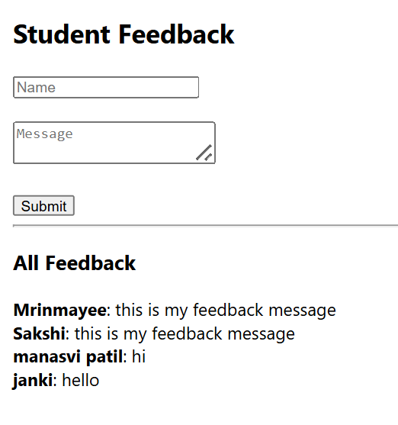
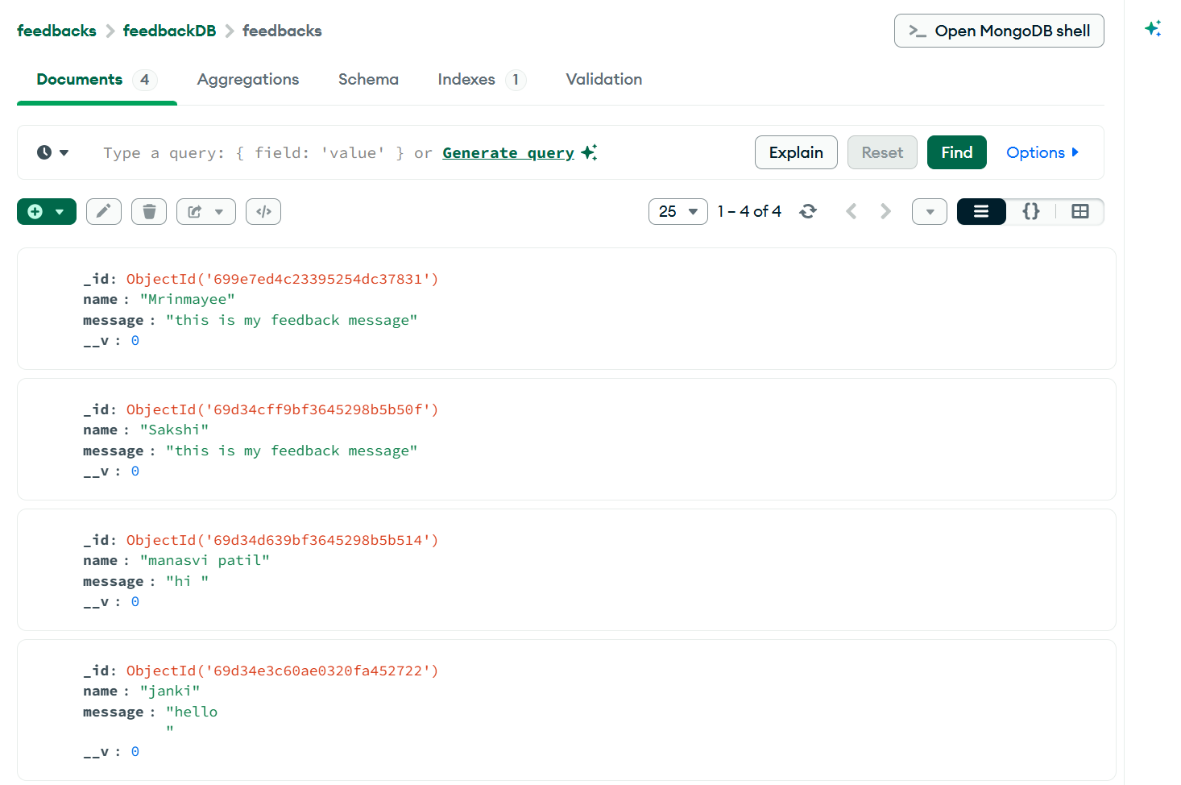

Conclusion
The Student Feedback Review System successfully demonstrates full-stack development using the MERN stack. The application performs data submission, storage, and retrieval effectively, ensuring proper client-server communication and database management.

